CS 255 System Design Document Template

This template lays out all the different sections that you need to complete for Project Two. Each section has guidance to prompt your thinking. You will need to continually reference the interview transcript as you work to make sure that you are addressing your client’s needs. There is no required length for the final document. Instead the goal is to complete each section based on what your client’s needs are. Remove this note when you are finished, and replace all bracketed text with the relevant information.

UML Diagrams

UML Use Case Diagram
The UML activity diagram illustrates a core DriverPass system workflow using a step-by-step process. Although the diagram was created using generic labels, it represents the logical flow of a user interaction within the DriverPass system.
In this context, the “Verify PIN” activity represents secure user authentication when a customer logs into the DriverPass system. The decision point for “Wrong PIN” reflects unsuccessful login attempts, while “Correct PIN” represents successful authentication. After logging in, the “Ask for Amount” activity represents the system prompting the user to select a service option, such as scheduling a driving lesson or accessing training content.
The “Amount Not Available” decision represents a situation where the requested option is unavailable, such as a lesson time slot or package not being available, and the system prompts the user to choose an alternative. When the request is valid, the system proceeds to complete the transaction, which is represented by “Dispense Cash.” In DriverPass, this corresponds to confirming a reservation or granting access to training materials.
The final steps, “Generate Receipt” and “Print Receipt,” represent the system generating confirmation details for the user, such as a lesson confirmation or transaction summary, before the process ends.
This activity diagram demonstrates how DriverPass guides users through authentication, decision points, error handling, and successful completion of a task in a clear and structured way.
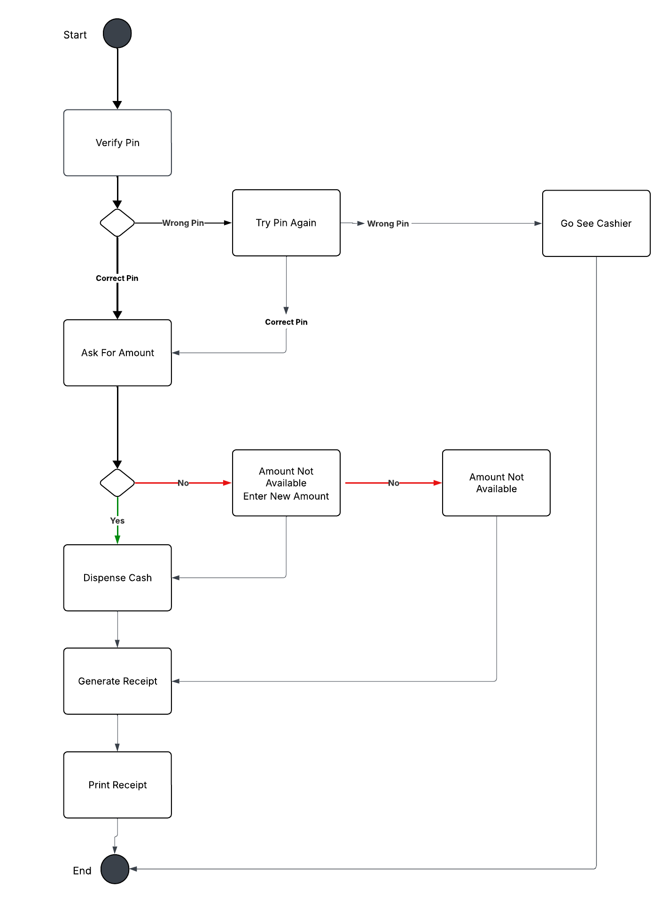

UML Activity Diagrams
Schedule Driving Lesson (Customer/Secretary): The user logs in, selects a package, chooses an available date/time, the system checks driver and vehicle availability, confirms the reservation, and logs the action for tracking.
Take Practice Test (Customer): The user logs in, selects a practice test, completes the questions, submits the test, the system scores it, stores the results, updates progress status (not taken / in progress / failed/passed), and displays the results.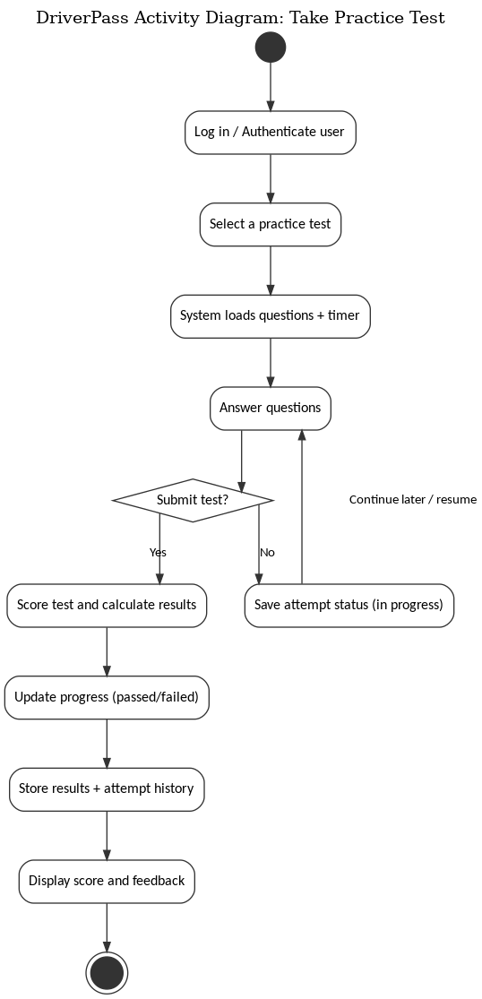
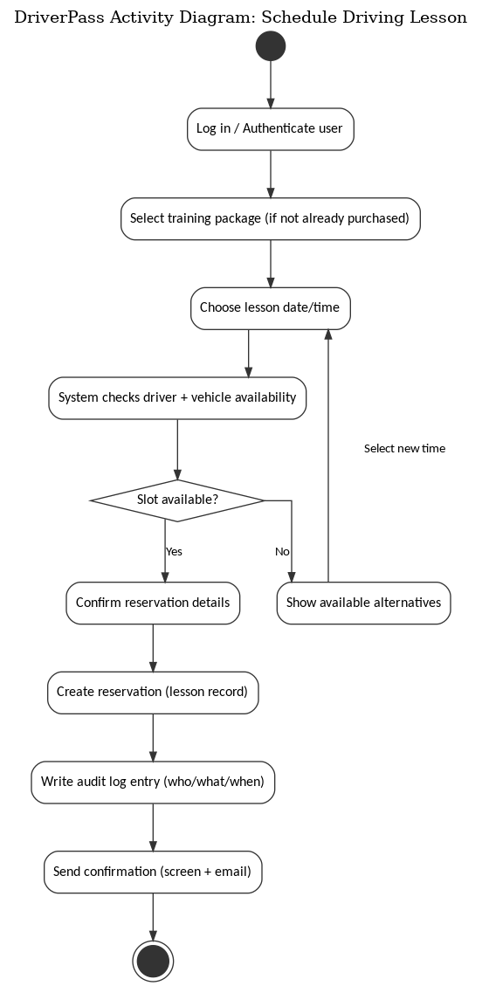

UML Sequence Diagram
The UML sequence diagram models the message flow for the Schedule Driving Lesson use case. It shows how the Customer interacts with the DriverPass web application, which then queries the database for package eligibility and available lesson slots, checks driver/vehicle availability, creates the reservation record, and returns a confirmation. The sequence also includes writing an audit log entry so DriverPass can see who created/modified/canceled a reservation and when.

UML Class Diagram
The UML class diagram captures the main data objects the DriverPass system needs to store and relate. Key classes include User (with roles such as Customer, Secretary, Driver, Admin, IT), Account/Credentials, Package, Purchase/Enrollment, Lesson/Reservation, Schedule/TimeSlot, Vehicle, DriverNotes, PracticeTest, Question, TestAttempt/Result, and AuditLog. These classes support core system features such as scheduling lessons, assigning drivers and vehicles, tracking student progress, storing lesson notes, and generating reports.

Technical Requirements
• End users: Computers and mobile devices capable of running a modern web browser.
• Web application accessible through modern browsers.
• Server-side application stack hosted in a cloud environment.
• Relational database to store users, packages, reservations, test results, notes, and audit logs.
• Reporting/export capability so the owner can download data for offline review.
• HTTPS/TLS for all data transmitted between users and the system.
• Role-based access control to enforce different permissions for Customers, Secretary, Drivers, Admin, and IT.
• Password reset via email verification; administrative password resets and account blocking handled by IT.
• Account lockout or throttling after repeated failed login attempts.
• Audit logging for reservation creation, modification, cancellation, and other sensitive actions.
• Cloud hosting with automated backups, monitoring, and high availability.
• A secure integration method to receive DMV updates to rules and practice-test content, with notifications when updates occur.
• Scalable storage for test content, results history, and lesson notes.
• Lucidchart for creating UML diagrams.
• Version control for development and a deployment pipeline for moving updates safely to production.

